The Kitty Family of Judy Lee- St. Francis Ministry- AS OF July 8.2018
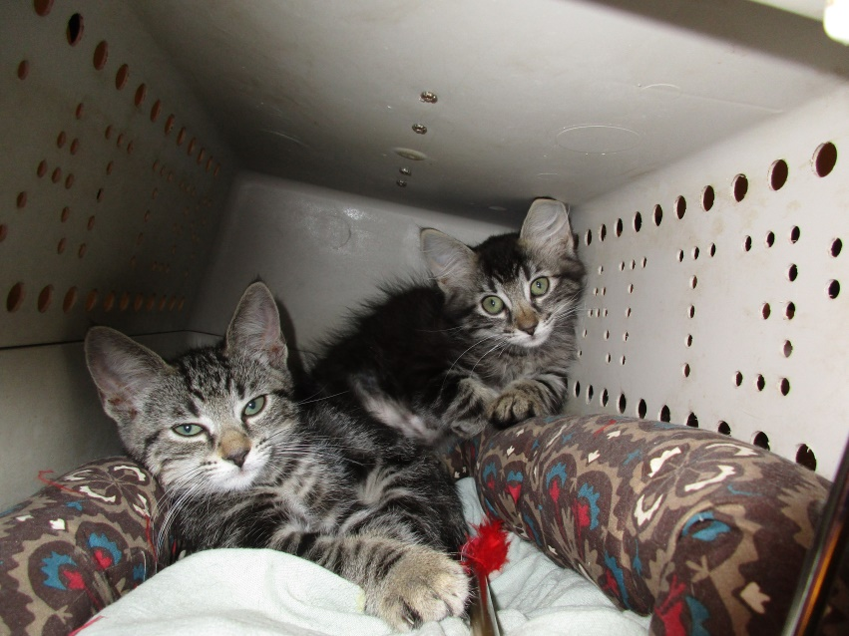 Trixie and Dixie
They walked into our lives by themselves at about 2 mos. of age in 2017 and when tamed and happy kitties they found loving forever homes with Cousin Jackie Marion and Pat Scorsone.
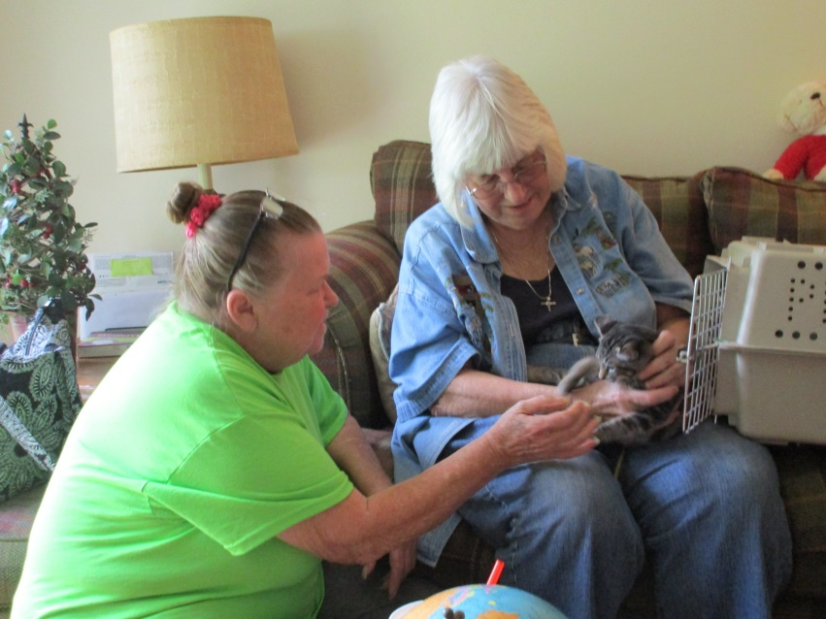 An Introduction To Their Stories
This is Pat Scorsone receiving Dixie after the loss of her cat Sarah. Sarah and Pat were only one of the several families we subsidized for pet care as part of our St. Francis Ministry. In addition to subsidizing the care of pets for those with little or no incomes, the St. Francis branch of Good Shepherd Ministry also rescued at least 30 cats, dogs and kittens that we were able to place with loving families over the last fifteen or so years. The cats in this story are those we kept as we could not find other loving homes for a host of reasons including age or illness.

