The Kitty Family Of Judy Lee- The St. Francis Ministry
July 2018- Starting from the “newest” first

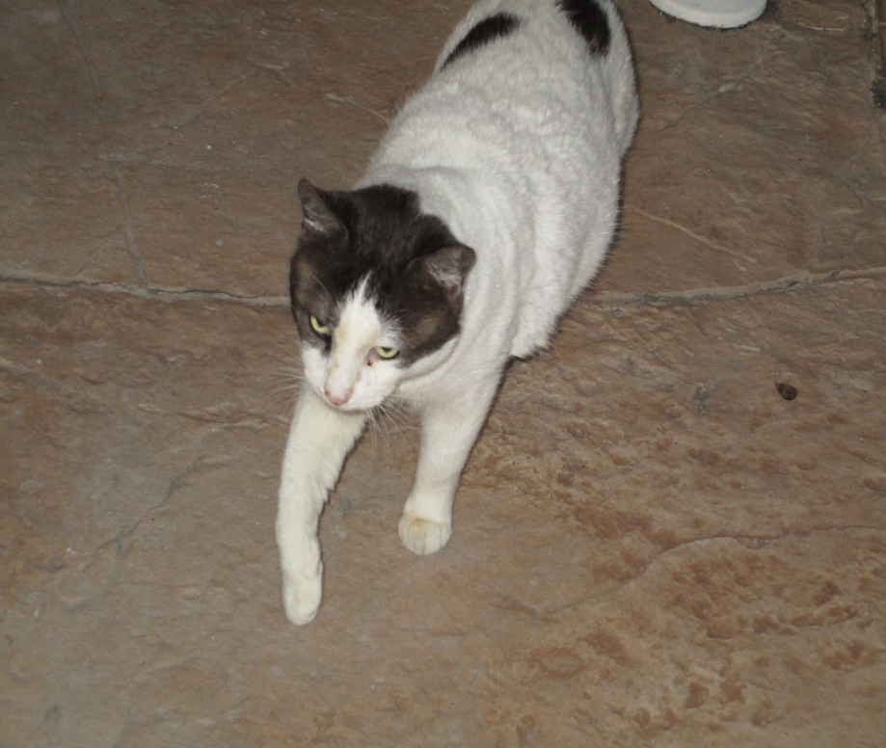
This is Sweetie Pie. He joined the family in mid-January 2018. He was an outside cat here for well over a year. Like most of our arrivals he lived in the woods across the lake. At first this TNR kitty was quite feral and fearful. He would eat and run. Gradually he came closer and stayed longer. He came always with two others. In mid January 2018 he came into the front porch, laid down and could hardly get up. He did eat and stay the nights. He allowed me to pet him. His body is muscular and stiff. A trip to the Vet, Dr. Terry Sutton, on 1/22/18 showed that he had bad arthritis and was FIV Positive. There was evidence of pellet shots embedded in his rear end. He may not hear well. He was thought to be at least five years old. Given pain meds and 3 yr. rabies shot. He was happy to move into my bathroom and in a few days regained normal walking. Within two weeks he enjoyed the lanai alone but the males took a good while to accept him. Within six months he made friends with the cats in the bedroom at night and is able to go everywhere and is accepted by all of the cats in the main area although he’d still rather avoid the dominant males. He remains a little cautious but sweet and friendly to all.
This is Tigger. He began to visit us as an older kitten- 8-11 months I think. He courted the others on the lanai by sitting near the screen and playing with them. He knew to be submissive to the older cats. When I walked outside he would literally grab me by the feet and hold on. He would then squeeze onto the lanai though the others hissed at him. He was affectionate and cuddly . After a few months of this I thought I could possibly get him a home. On 6-22-15 I took him to Dr. Terry. He was a well cat considered to be about a year old. He got a one year rabies shot and passed all tests. He easily moved into the renovated garage with Bonnie and her two kittens, now a few years old. They became friends. He is high energy,smart and active. In a short while he could also join the cats in the main area and on the lanai. I put his pictures up and went online and tried all I knew to get him a good home. He is an active and large Tabby and I could not see him sitting in a cage in Target or Petsmart with HEAL. He is now also a dominant male with some but is chastised by the older ones. He remains loving and sweet. I think he could still use a loving home with only 1-2 cats and good space to play in the house and in a screened in area.
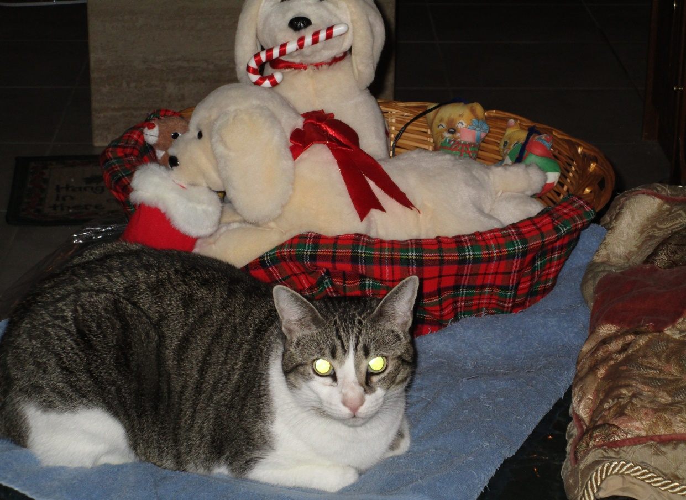

In December of 2014 we took in Mama Bonnie and her two kittens, Baby Benny and Markie (Marco Polo). For three months or so Mama came every day for food with her small kittens following-maybe 2-3 months old. Big Benny, perhaps the father, led them here. Big Bennny ate regularly outside for 1-2 years before bringing them. ( In 2016 Big Benny parked himself on the front porch and was visibly very sick. He stayed in the bed and shelter on the porch and I was able to bring him to Dr. Terry. He had Feline Leukemia. Within 2-3 weeks he passed away in his bed on the front porch. Not only did he bring his family to safety but he came home to die). Baby Benny is white with dark spots like the Dad though he is a long hair and his spots are striped and not only black.Marco is a perfect little Tuxedo. Mama is white with a few black markings too. It was amazing to watch them come one after the other from a large garbage ditch on the corner a long block away. They were very frightened but learned to eat on the front porch. Marco’s name is because he was a little adventurer, often lagging behind and playing then come running. I tried shutting them in on the screened front porch but they got out through the screen at night. Finally I got stronger screen and herded them into a large carrier. They were neutered and spayed and received their shots and moved into our finished garage, (no cars) once a teen’s recreation room and laundry room. After a period of hiding under the bed they enjoyed the cat trees and looking out of the garage windows. In time I could pet Benny and Markie but not Mama. They were not ready to be “caught” for adoption. She taught them to be a little wary, but every so often they love pets and playing games with treats as rewards. I screened in the side door area and they sit outside every day but mostly they like the inside storage room where they can climb to the top of cat trees and a tall wardrobe and sleep. They accepted Tigger easily and venture into the house and fron porch with him sometimes. But, because the main area cats are so dominant they mostly stay in their rooms and therefore do not have enough human company to become fully trustful. They are beautiful and young and could attach more in a “more normal” (less cats and more time for attention) loving home. They love pets when they come to you, but not to be pursued.Maybe even Mama who is less cautious by now could learn to trust more. First below is Bably Benny, then Marco, then Mama Bonnie and Baby Benny. 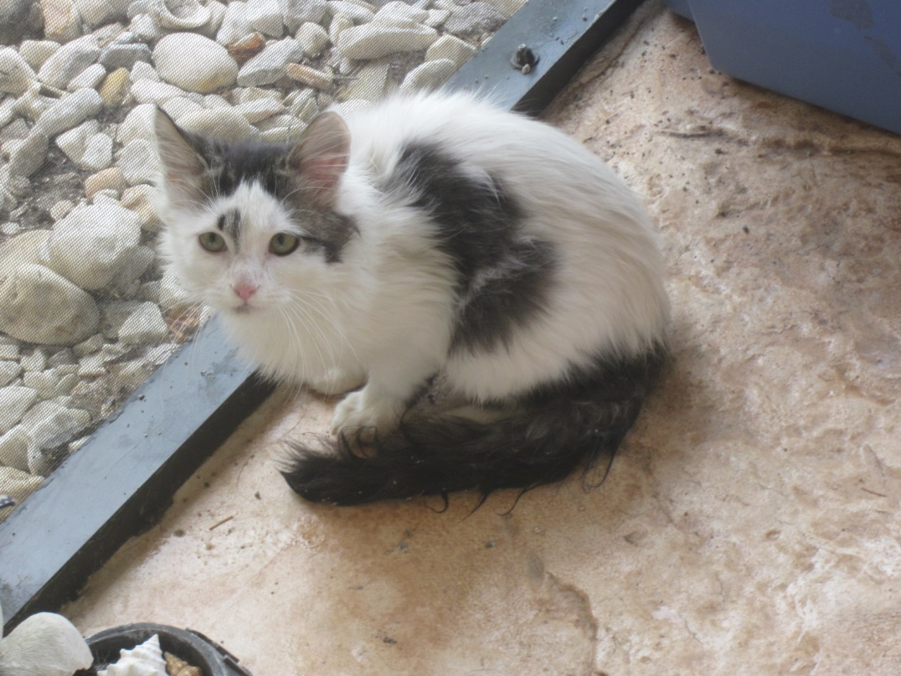t 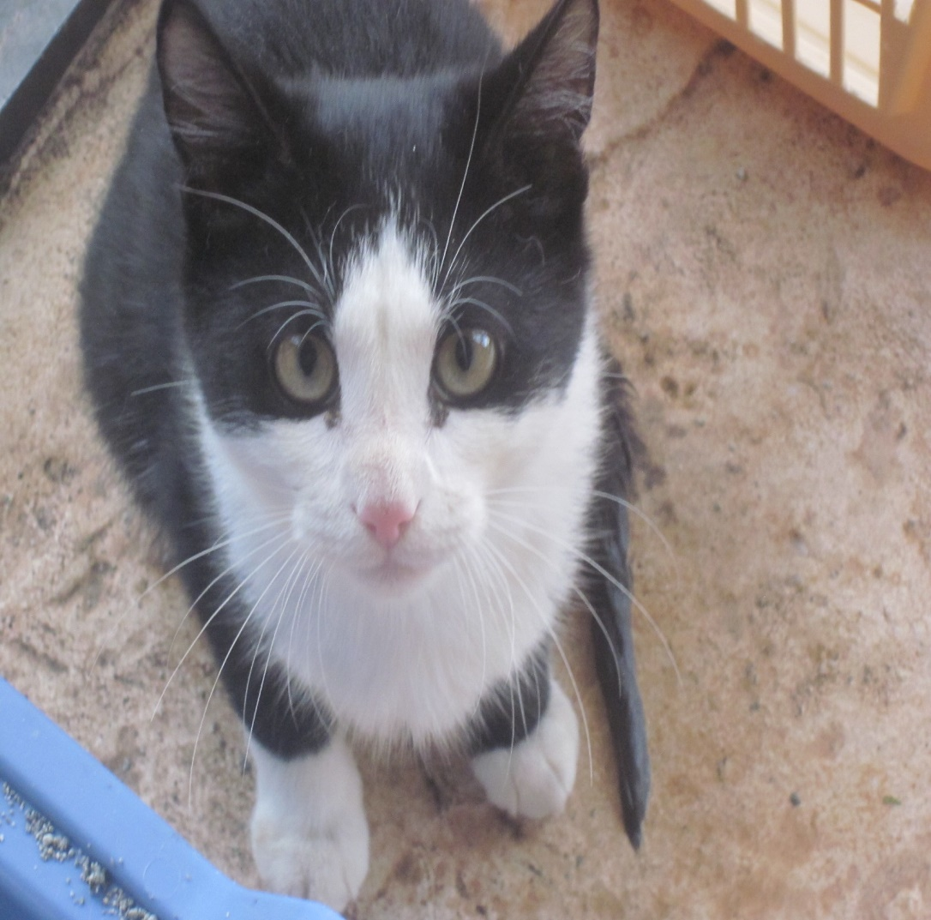
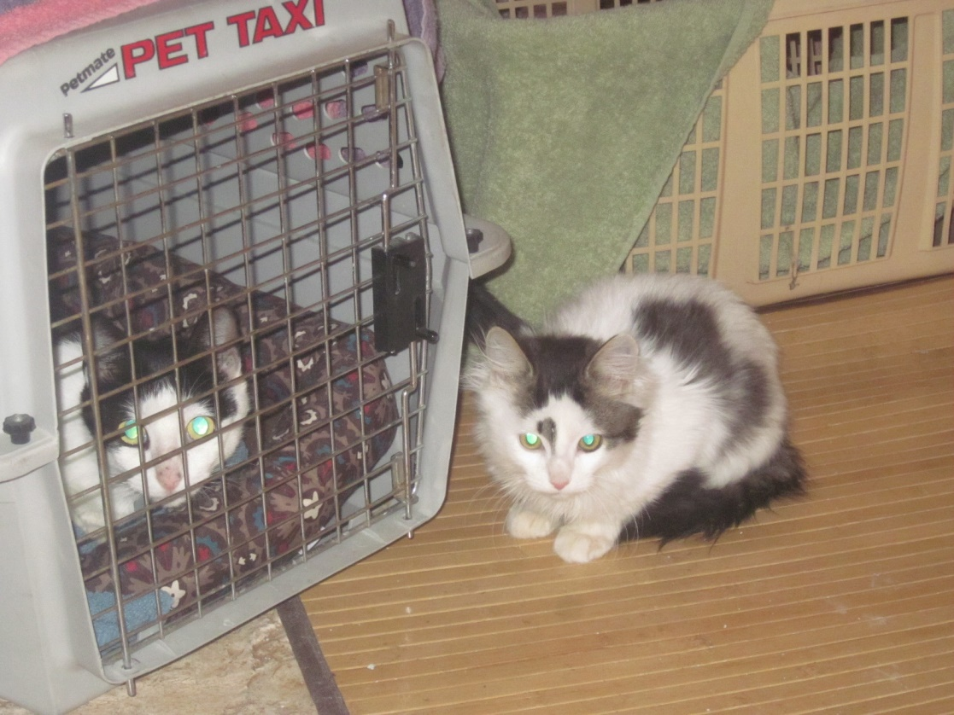
Sammy (Satin) and Velvet (Below)
Two young cats, (or older kittens) tentatively joined Big Benny in eating outside at night. They all came out of the woods. In October of 2014 we took in Sammy (Satin) who is the brother of Velvet (Velly) who came in in June of 2014. They had similar white markings but Sammy is black and white and Velvet grey and white. Velvet was able to come close and then to enjoy pets. He was always hungry and eager to come in. On 6/24/14 he was taken to the Vet and determined to be about 9 mos. old and FIV+. Neutered and all shots given. Sammy was always totally frightened and kept his distance so we could not easily catch him to come in. But he kept on coming to eat daily after Velvet came in. By October he was not as strong and perhaps getting sick. I used the True Trap and took him to the Vet. He was given an antibiotic and then shots and neutering. He was not FIV+ but very feral. I let him loose in my bathroom but it was months before he would come out of the closet. The others did not go in to see him as he hissed. Eventually he graduated to under the bed in my bedroom where slowly he interacted with his brother and the others. He became close friends with Star who has the best disposition. After about six months he ventured into the main house and eventually became comfortable. But he remains the only one in the main area who is afraid to go out to the lanai via the cat door or regular door. Once in a while he ventures to the front porch. He loves to climb the cat trees and now sits on the bed with Star and others even when I am in it. He allowed me to touch him a few times.
Unlike Sammy, Velvet is friendly and affectionate. He is in the inner dominant male group with Brooklyn and Socks and loves to cuddle with Socks.
Below is Sammy (right) with Star- Sammy loves Star who eventually tires of Sammy’s attention but is usually great with him.
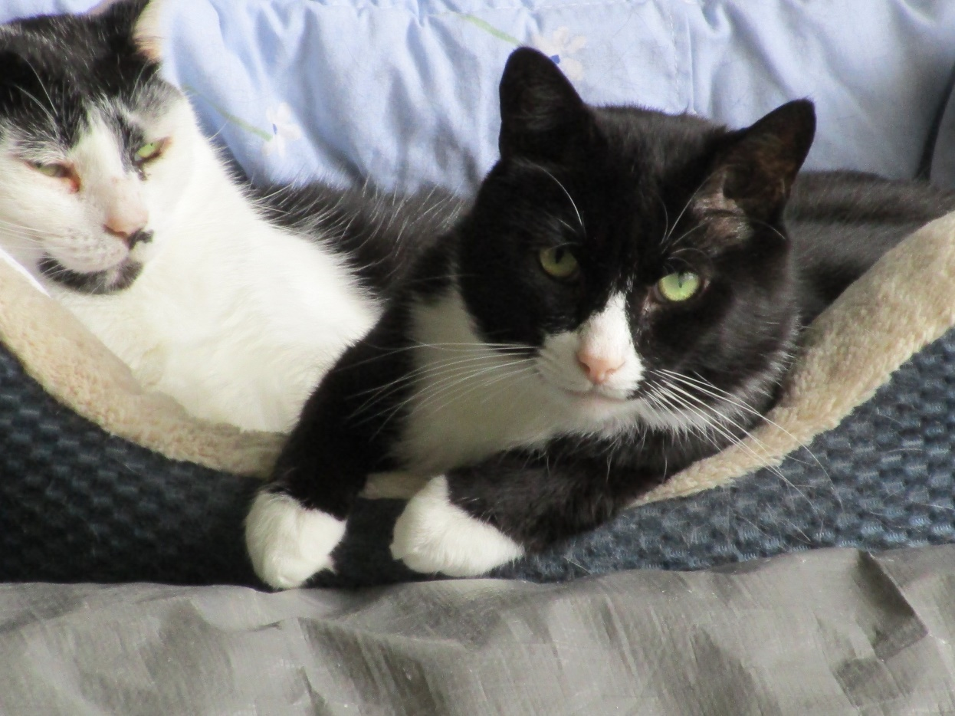
This is Velvet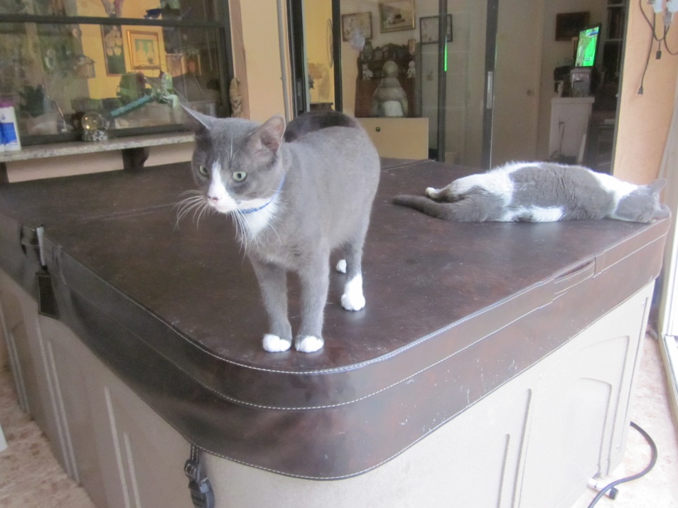
(Sleeping Near Velvet is Potsy-Peter Potter who was with us from 2013-2017 when he passed of kidney failure and FIV+ weakening his condition. He was a sweetheart from the woods across the lake who literally dropped in from on top of the lanai where he ate and then lived in a carrier. Once he dropped in he visited Dr. Terry for neutering and shots and was happy to stay in my bathroom until he joined the kitty family and lived a happy life. (In 2013 too we took in Bushy Tail a young striped long hair whom we were able to place with Ginger Delerme then an older woman named Garnet who loved him dearly until his death a year and a half later from Feline Leukemia) It is so hard to lose them but it is good to provide them loving homes until they pass “over the rainbow bridge”.
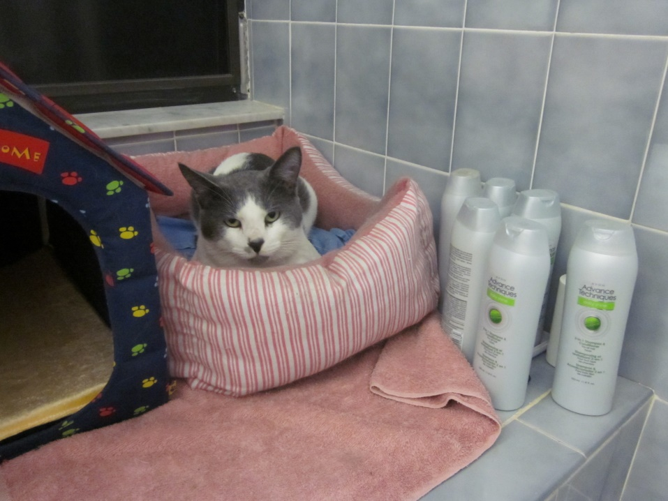
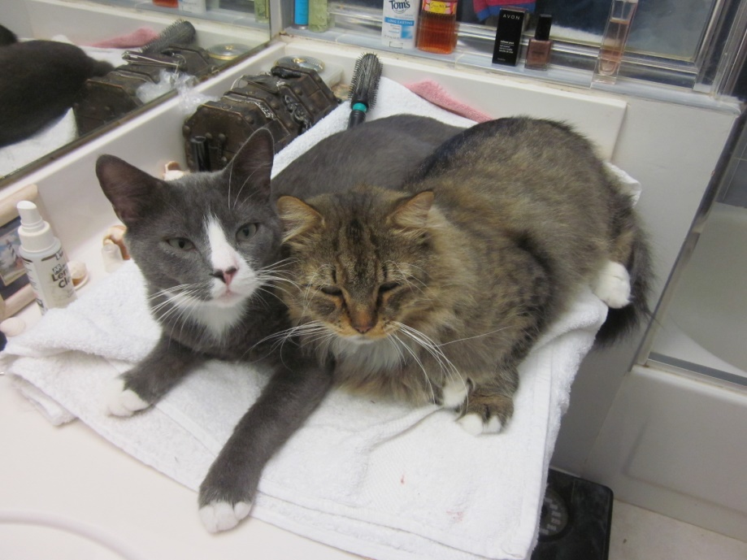HERE IS VELVET WITH SOCKS-SOCRATES
Socks, a beautiful Maine Coon Cat, also visited when Velvet did in the Spring of 2014. They may have known each other outside but Socks was a very frightened cat, like Sammy. His hair was a bit matted but he came every day for his dinner and stayed at the farthest point and watched. In May of 2104 I used the true trap to bring him to the Vet, Dr. Terry. He was healthy and ready to come in from the outside as storms gathered. Neutered and given all shots on 5/14/14. He was so frightened that I put him in the renovated garage to be farther from the dominant males. He hid under a shelf in the garage for four months only eating when I was not present. I would talk to him each day. Then, at the end of the four months he came out and rubbed against my legs and allowed me to pet him. I slowly integrated him into the main area where he got along with all of the cats and began a very happy life. He and Velvet are especially close.
Below is SOCKS- Socrates He is sweet, affectionate and loves treats.
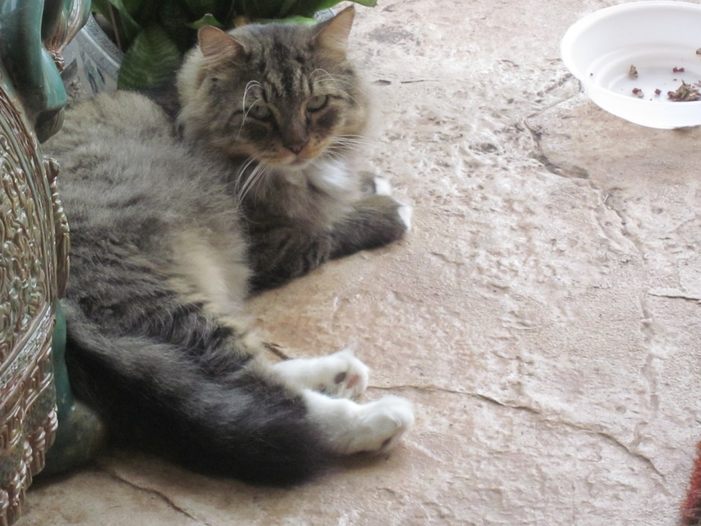

BROOKLYN BIGADOO ( Below) came into our lives in 2012. He came day and night for months for feeding and attention. A large Siamese and tabby mix with crossed blue eyes and brown fur with stripes, he liked to sit on my lap though one day gave me a quick “love bite” on my arm that caused a major infection, Bartonella. At that time (July 2012) I took him to the VET, Dr. Terry, and he was found to be healthy except for a problem with right front tooth, and already neutered. He was around 3 years old and had a chip from a Naples Shelter traced to a woman in this wider neighborhood. She did not answer the phone. No record of shots or Vet visits as far as we could find. We gave him his shots. But as he literally had moved in here and ran the streets day and night I agreed to adopt him. He became a happy camper never trying to get out again. However, he did have a bad habit of marking his territory that eventually caused me to cover all of my furniture with plastic. As he was a large dominant male others occasionally followed but it was his problem. This may be why the woman let him out at all times but he was clearly able to use the kitty box most of the time. At this time he is doing this less and relates well to all of the cats, cuddling with Silver and sometimes Velly and Socks and Star. Yet he is the leader and the problem unfortunately remains with him from time to time. He remains a very sweet and affectionate kitty.
( In January of 2012 we also took in SKYE a beautiful young blue grey striped Tabby who appeared at our lanai door with a smashed and broken tail and whatever caused that also wrecked havoc with his urinary and bowel functioning. The tail had to be removed and he needed Vet assistance with his bowels from time to time. The urinary problems did not appear until later. He was so thankful for a home and so affectionate, we called him the Ambassador as he greeted our guests and didn’t run and hide like the others. He was closer t Judy and I than to the other cats but was sweet and friendly to all beings. Losing him to the complications of his internal organ paralysis in November or 2015 was very difficult for us. Dr. Terry’s caring treatment of him is just one more example of her skill and dedication and ability to help with the toughest decisions. But we treasured his three years with us. In 2012 we also lost Navidad, a beautiful small girl Tabby with a white bib who came to our front door hungry and shaking and already spayed in 2010. She unfortunately had a serious thyroid problem. We administered her meds daily and she loved her life with us but she succumbed to thyroid problems in two years. She was so sweet and loving that her departure was also very difficult. )

THIS IS BROOKLYN
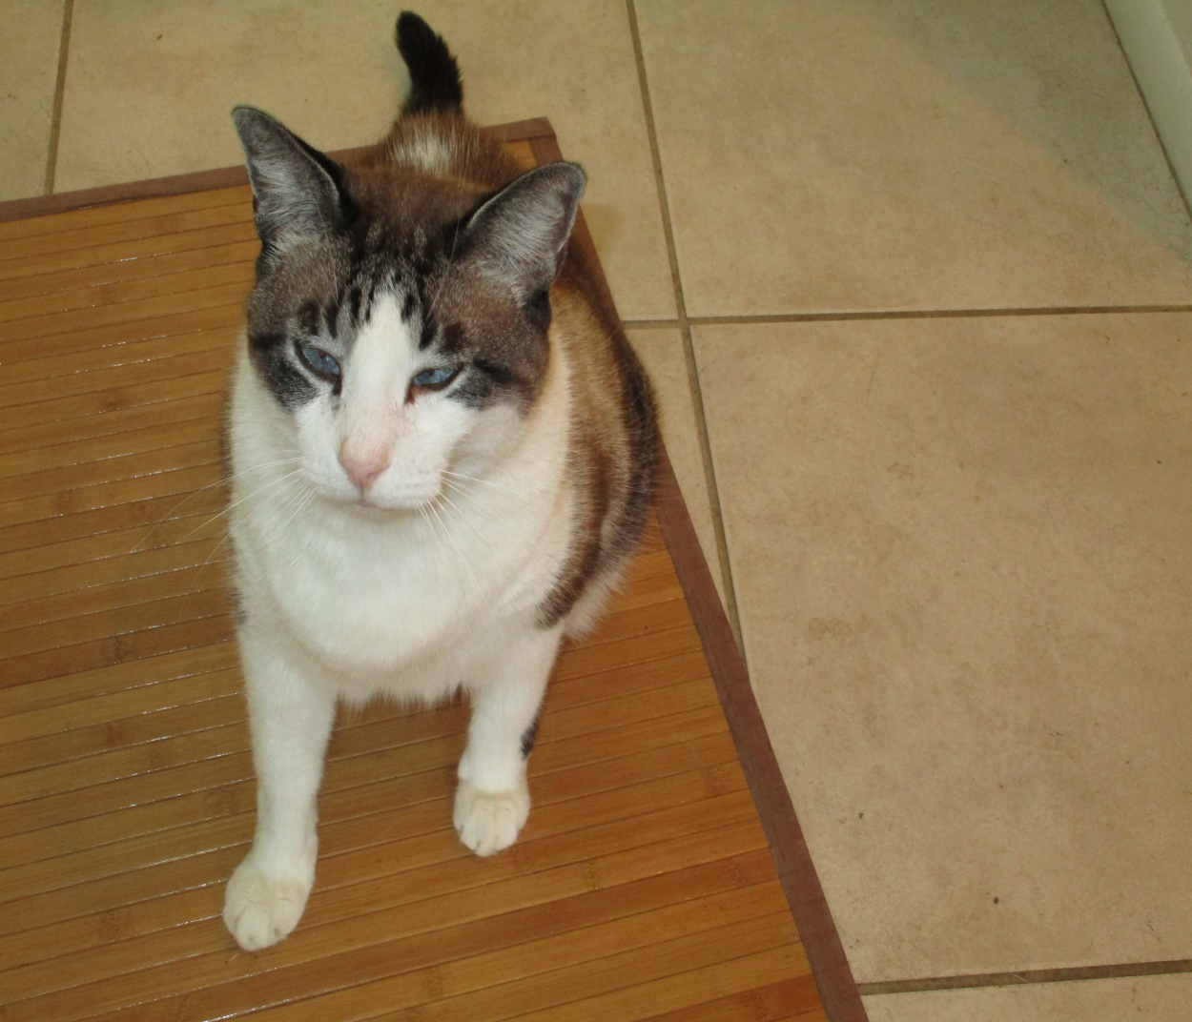

In February of 2012 Mary Jane, a beautiful female Tuxedo kitty, came to our lanai door hungry and crying and asked to come in. Most who come this way are from the woods across the lake where many cats are dumped. Within a few days we took her in. She was healthy and we had her neutered and gave her all of her shots. In Jan of 2016 it was discovered that she has a heart Murmer lll/VI. Three yr. rabies shot given. She was from the start very affectionate and not afraid of guests. She got along with Skye and was our other Ambassador. However, she did not like most of the males and would hiss and strike at them or respond in kind when they get too close. She likes heights and could manage with the males by going higher than any of them on shelves, cabinets, etc. One of her beds is on top of a kitchen cabinet. Another is in a bassinet where she hides under the mattress. And she loves the bed on my desk where she looks out of the window. She goes on the lanai occasionally and into my bedroom very occasionally. She copes well and loves human company so greets all of our friends.
However, she does have some problems. One is very unusual- she pees in wall outlets, spraying like a male. It took a while to discover this but she effectively disabled some outlets until we noticed. We have used outlet covers and put plastic over all outlets but she is still attracted to the telephone outlet on the kitchen counter. And, sadly although she uses the litter box for defecation she does pee in other spots when the boxes (we have 8 where she can get to them) are already used. These spots can be anywhere and one has to be vigilant to find them. So, if she did find a home where she would be loved as she is here, for she is attached to me, (and I to her) the person would have to be patient with her poor and strange habits that came with her and have few if any male cats. She may well be better off here with us since her habits, especially spraying the outlets will not change. Yet, she is MS. Personality!
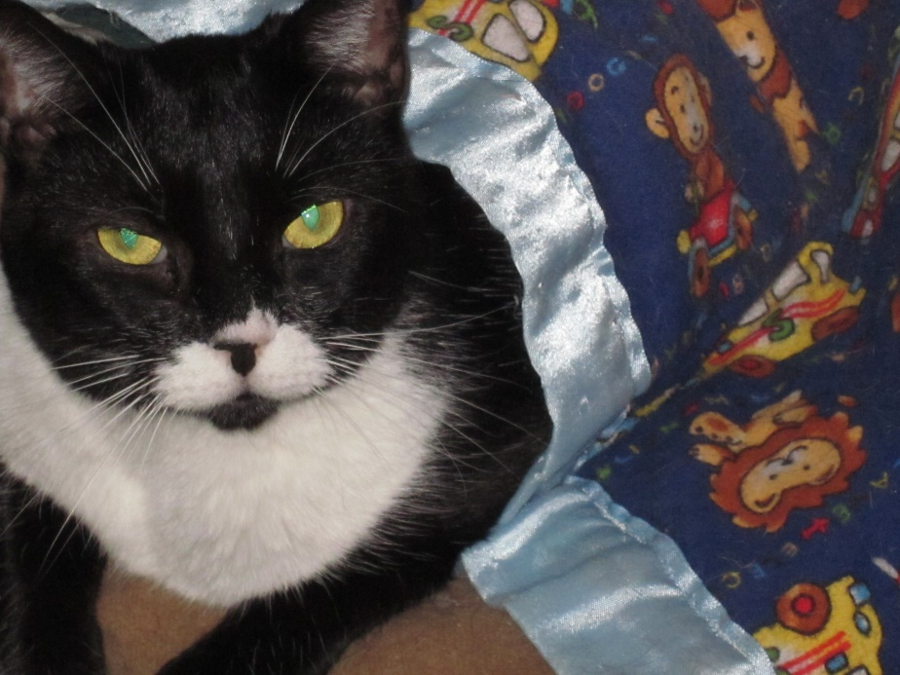

In April and March of 2011 respectively we took in Goldie, a small young brown tabby and white girl and Silver a beautiful Russian Blue boy. Both appeared at the lanai door nervously begging to come in. Both were friendly healthy, spayed and neutered and given all their shots.
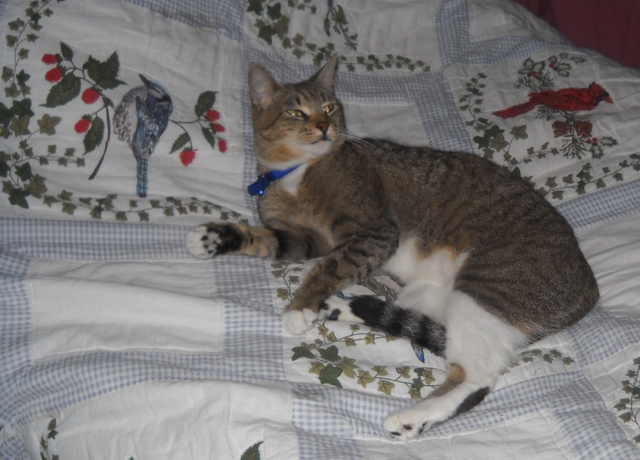
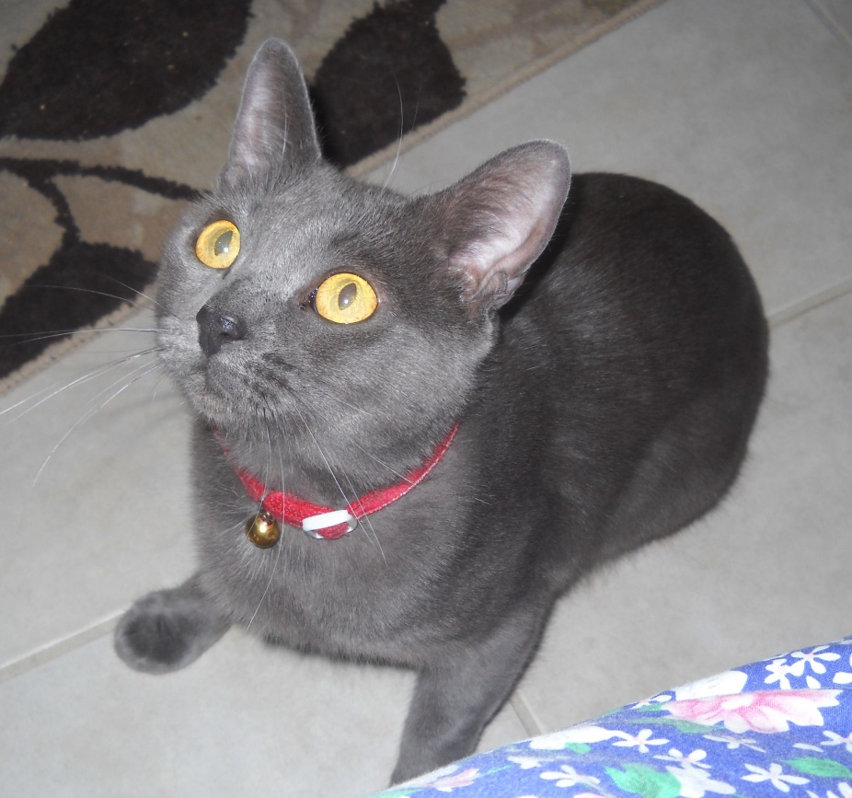
Both are healthy although Silver had a bladder blockage and polyp on his bladder wall in June 2018 and is well after ten days of intense treatment. He is a real sweetie but sometimes, although smaller, he “gangs up” with the dominant males. Mostly , however, he seeks affection and treats and sometimes cuddles with other kitties and with me. He loves that and purrs away. Goldie (Golden Dancer because she dances when she walks) is affectionate with me but scared of all others cats and people. She carves out her own space in the bedroom and bathroom and enjoys her solitude. She likes to lay next to me but will only do so when other cats are absent or asleep.
STAR is a star here by look and disposition, getting along with all here with gentle affection. He came to our front door in 2009 and charmed Angel, our wonderful big dog who to that point did not like cats. As Judy and I and Angel sat in the front Star simply came up to Angel and rubbed against her. To our surprise, Angel took right to Star. Since she was about a year old in 2001 we had to keep the smaller dogs, our beloved Rafie and Beau (and later Cody) and all cats separate from Angel. She was short tempered perhaps because of her serious heart condition. Minnie and her four kittens, all grown cats of five years when we moved here in 1998, stayed on one side of the house here, and Angel lived on the other. Later Timmy and Henry (2003 and 2004) and beloved easy going grey and white Francis (2004-2010) lived in the garage and came into the house and on the lanai when Angel was in the bedroom. Angel was befriended by Star and when we took him in in approximately September of 09 Angel allowed Star to sleep with her. Angel’s big heart gave out in September of 2010, but by then all of the cats and ,cautiously, even little Cody the tiny Maltese (and Judy B’s heart) we adopted from a homeless man after Cody was locked in an abandoned building, could be in her presence. Perhaps aging had helped her to mellow but Star’s very special gentle disposition had a lot to do with it. To this date Star with his whimsical half moustache still gets along well with everyone, including the most frightened cats here and he is especially close to me.
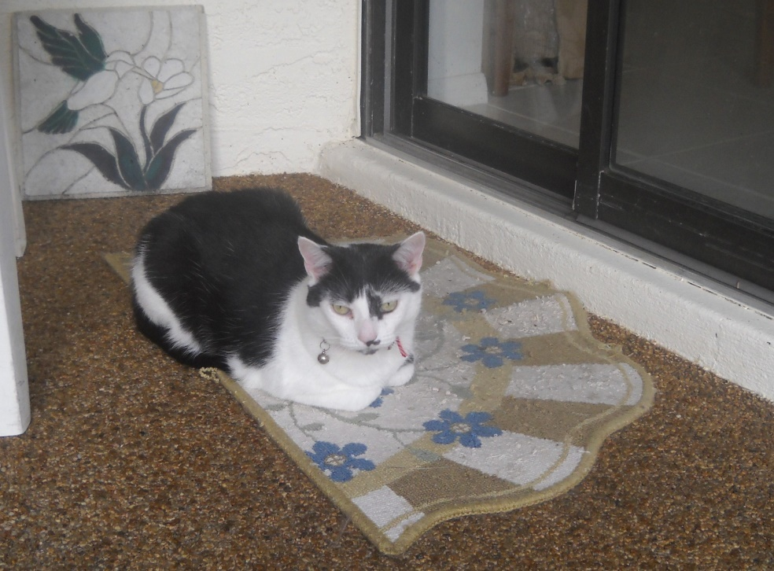
In early 2008 a homeless woman in the Park Ministry gave us two small black kittens. ( Before that she gave us two gorgeous white kittens that we gave to Sonja Miller.) One, a black and white, we gave away easily and when no one wanted the one that was all black we kept him. Judy B and her friend Sr. Johnette who was visiting named him Brother Maurus and he lived on Judy B’s side of the house and was really hers. She called him Maurus Kitty and he loved sitting near her as she did her work in the office or rested on the bed. In November of 2008 the male partner of the same woman who gave us Maurus told me that the woman had left him as she could no longer live in the woods. They had cared for Lady Guinevere and her six current kittens. He was so upset that he got drunk and stepped on and killed one of the kittens and he asked me to meet him in the woods to take Guinevere and the kittens. When we did this we were so surprised that when we put the carrier down and opened it, Lady Guinevere, a beautiful Calico, and her five kittens all scooted into it. An older male kitten (maybe 8 mos. old) wanted to get into it too but the man wanted to keep him. When we took Lady and the kittens to Dr. Terry we learned that she and three of the kittens were FIV+, two were not. Lady Guinevere was spayed in a few months and all received their shots, neutering and spaying. We know of at least three separate litters of Guinevere-and maybe there were more. A Vet tech immediately adopted an orange and white one that was free of FIV and in about 5 months we found a home for Leo, a little striper, that was also free of it. We named the remaining three Winter (white with smudges), Elana a dark striper with a white chest, and Sir Gallahad, a big striped and white male. Within a year they tested negative for FIV but by then they were big and not wanted by anyone. So they all lived with Brother Maurus on “Judy B’s side of the house”. Maurus, contrary to what some say, knew his mother right away and was happy with her being there. He got used to the little ones and has a special close relationship with Elana. Winter and the Mom and Sir Gallahad, Gally, also cuddle together. We built them a special lanai and they enjoy going out there twice a day every day and also coming into the main house area when the others are outside. When Judy B was well they were happy because she spent hours in there with them every day. Her illness of the last two years took her from them especially in the last year. Now as of Jan 1, 2018 she is with our loving God and I hope her beloved family and dogs. I visit them and try to stay there a few times a week but they don’t have enough human contact. I wish they could find loving homes together in some constellations. The Mom and girls are fine. Elana is always hungry and very verbal. Winter had a cystotomy-stone removal- in 2015 and is fine now. Gally is a big , strong and active tabby and white male that could use more attention and more space as well. He is sometimes testy with Maurus who tries to ignore him, but I have felt he could use a loving home of his own even before Judy’s illness.
In the first picture below are Maurus and Gally and Winter. In the picture after that are Winter and Lady Guinevere.

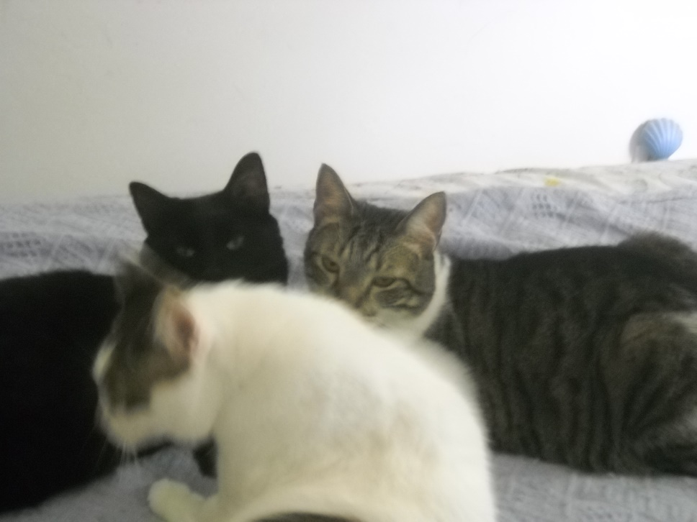
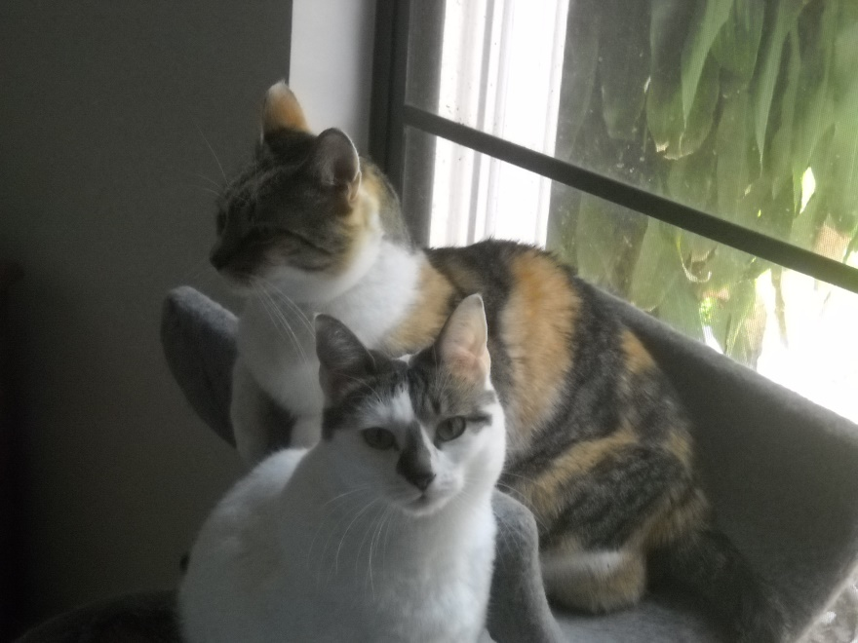

The picture below is ELANA, but I wish I had one of her and Maurus cuddling as they are so close. Now they are here for ten years and still all act like kittens!
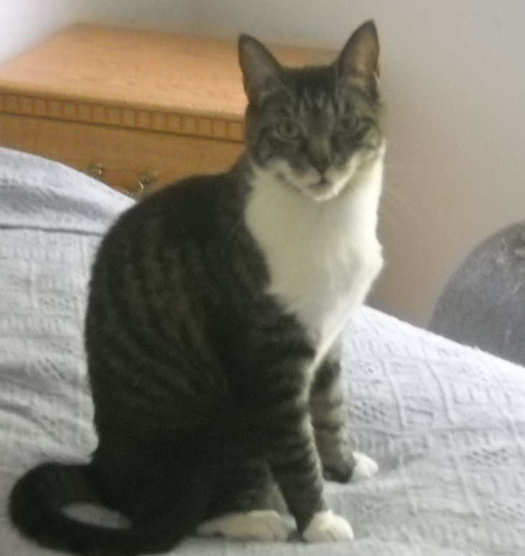 Elana, Lady Guinevere’s smaller girl.
And last, but not least are Timmy and Henry, brothers with the same perfect rubber stamp noses, who came to live here in late 2003 and 2004. Timmy, a beautiful and perfectly marked and proportioned brown and white tabby who was initially timid came to us as he watched our other cats (brought here from Connecticut in 6/98) enjoying and eating on the lanai. He was probably a year or so old and very hungry. That is when we first realized what a dumping ground the woods across the lake were. We saw Henry a pretty black and brown tortoise marked kitty with him at first, then he seemed to have disappeared. A few months after taking Timmy in we heard constant noise on the roof. Eventually I climbed up on the shed and looked up to see Henry looking down on me. We opened the garage door and let Timmy sit outside. Henry came down and followed Timmy back in. He was given his shots and neutered on 6/24/04 and both were healthy. They got along with large sweet Francis fine and enjoyed their trips to the lanai. They were happiest when Star “changed” Angel and they could have free run of the house too.
On 3/31/16 after 3-4 months of living with a growing cancer on his right front leg Timothy had his leg amputated. We were very worried about this surgery but he recovered within a few weeks to a month and can do everything on three legs. Timmy and JudyB. grew very close as they battled cancer together. Timmy likes talking and they had great conversations as she was infinitely patient with him and they rested in bed together as needed. We were so proud of his courage and strength to fight and survive. He was a lot like her. As he also started having kidney problems and needs hydration 2-3 times a week one friend suggested that I let him go when she died (on Jan 1, 2018). He truly misses her but he fights so hard to live in amazing ways and I will let him go when he is ready to go. It is not now though he has lost four pounds, from 12 to eight pounds since his surgery. It is two years and four months later and he is still doing his best to live. I like to think that when he no longer fights to live he will join Judy B and they will continue their conversations. Henry and he continue to sleep together often but he likes being in my room more and Henry prefers the lanai. Henry shows some signs of “senility”, like peeing wherever he likes if he sees other cats where he wants to be, but both are still loving life and hanging in there. They are at least sixteen and maybe eighteen. Below are the two loving brothers together. And Timmy at Christmas after the surgery. Then, Timmy resting and talking! . 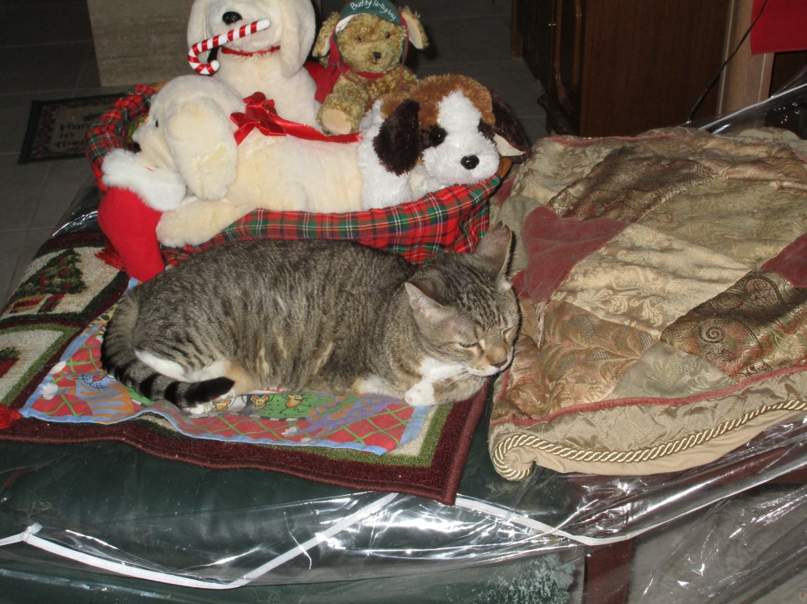 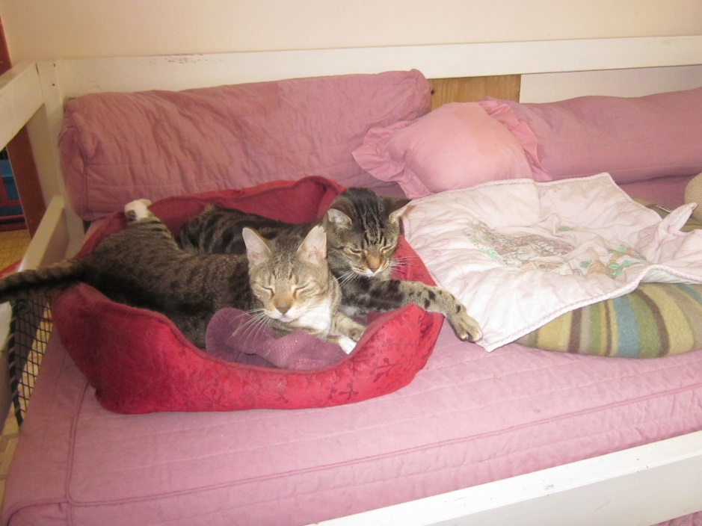
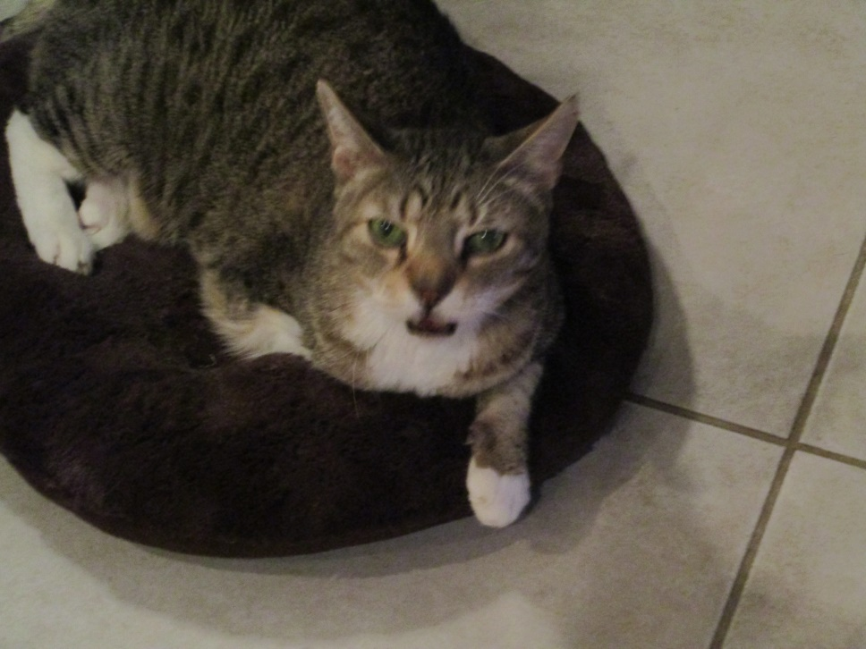
AND THAT’S ALL FOLKS! Timmy has the last word.

(On the next page is an earlier picture of dear Timothy and one of Gaspare who helps with the care of the kitties and the birds (only five of the flock remain now). Gaspare began his work with us in March of 2013 after my stomach surgery. They love him. He is with one of his little dogs and Skye is looking on in the background, not so sure of the visiting dog!)
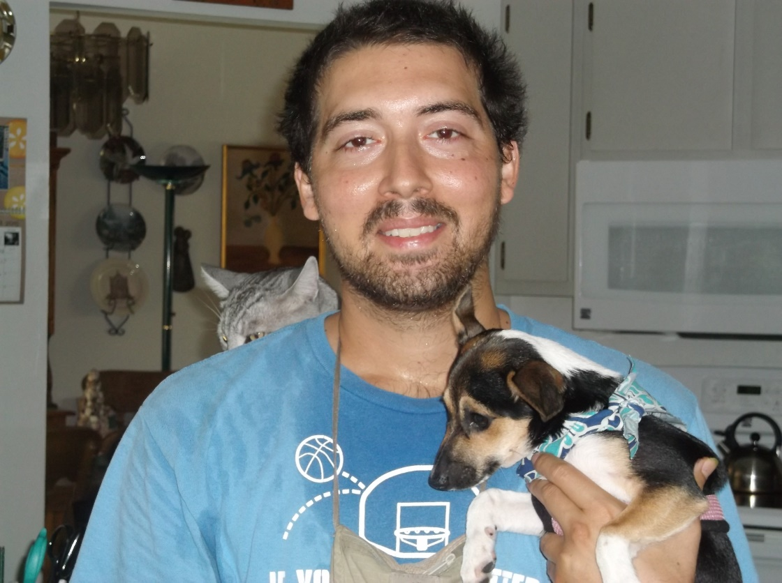
Our Helper and Friend Gaspare Randazzo who does a great job! And below, Timothy