Chapter 18
The Long Walk Home
For a woman of deep and vibrant faith, like Judy Beaumont, all of life is the long walk home with so many turns and surprises. The journey is at the same time the destination and we have captured some of Judy Beaumont’s exciting journey here in this volume. We have probably missed more than we captured of such an amazing life, but the snapshots in time tell the story as best we can.
When I was a young teenager I had two best friends, Barbara Jean and Judy Marie. Barbara and I lived across the street from each other so we would see each other all the time and saying good-bye was not an issue. But, when we made friends with Judy Marie we would walk her home several city blocks away after she visited-usually after church. Along the way we would link arms, sing, do little dance steps, and joke and talk. When we got to Judy Marie’s street, we would all hate to say good-bye, so we all walked back to my house again. Then we’d walk back again with Judy Marie. This would go on until she was about to be late for dinner and then she would leave and we would bid her good-bye. Even then, in the beginnings of everything, good-bye was hard to deal with. We all held on as long as we could.
Yet, there comes a time when one has to go home to God. This is a final journey, when we become conscious of the transition home to God and when we are ready to cross the bridge. For one who whole heartedly loves God and follows Christ with all her might death is not a wall we slam into at the end, but a bridge- a bridge we cross to oneness with Christ, with the Three-in-One God, a perfect relocation to the heart of God where we live, whole and vital once again.
This part of the journey home began for Judy in early 2016 when she was experiencing a new kind of fatigue and was diagnosed with MDS-Myelodysplastic Disease/Syndrome- a bone marrow disease and stem cell disorder where the bone marrow eventually can’t produce normal red blood cells, white blood cells and platelets. This can progress to AML, Acute Myeloid Leukemia, and about a year and a half later in April of 2017, after entering an experimental drug trial that took her off the meds that were working and left her unprotected, her MDS would make that fateful turn. Her diagnosis could be written sAML as sAML is the shorthand for AML that was preceded by other cancer and cancer treatment. The Doctors said that it was likely that the treatment for her APL Leukemia and/ or the radiation from the breast cancer led to the MDS disease. Judy and I had walked home together for over 28 years at that time. I was honored to be able walk this last walk with Judy, as was her sister, Jill.
As we noted earlier in this book, from 2005-2006 it was touch and go with Judy as she was treated for APL and had terrible secondary infections, painful reactions to the mega antibiotics, and long hospitalizations. However, by the end of 2006, lots thinner and nearly bald, she was finally going into remission and by 2007 she was recovering and considered “cured”. She felt healthy and strong. She was pleased that her beautiful full head of hair had returned-symbolic to her of life. The word “Thankful” could not capture our feelings although it was in the right ballgame. The remissions and the final cure was an answer to our fervent prayers and those of so many others for her throughout the world. This miraculous cure gave her and me too, the desire, energy and renewed call to serve our God in ministry full-time. Chapter 14 on Good Shepherd Ministry and those following describe her grateful response to being cured of APL. When diagnosed with MDS she was unpleasantly surprised but also expressed her deep gratitude to God in that she had ten years with no symptoms and eleven years of health enough to continue her service to the poor and outcast. She always looked to what she had rather than what she did not have.
In that spirit she continued with Good Shepherd full steam ahead until the steam decreased and ran out. She co-presided at our Mass and organized and helped to serve the meals afterward. She served individuals that she was responsible for as a Rep Payee for their Social Security Disability benefits, and she began to help them and others make good plans for their lives without her to lean on. We moved the Mass and meal and the “Tuesday ministry” with the homeless to once a month after several months of doing all she could do every other week. We held on to the “church building” where two women also lived. Patricia, 66, was making a transition from homelessness- from living in the woods with her precious cat, Sarah, and our Sister Priest from South America resided there. They prayed together and enjoyed each other’s company for meals. In 2016 Judy co-presided with Bishop Andrea Johnson and me in the Confirmation of seven Good Shepherd members, ages 10-67 who wanted to “seal the deal” as Father Al Jaenicke once said to me, and to receive the gifts of the Holy Spirit in following Christ. (In April of 2014 sixteen other Good Shepherd members ages 12-62 were confirmed by Bishop Bridget Mary Meehan). Pat, Catholic from birth but alienated, divorced, and outside the church for many years and reunited through Good Shepherd, was among the seven. On this day we were especially joyful as we were in looking at Pat and this group affirming faith in Christ, the beautiful fruit of our ministry.
By the Autumn of 2017 Pat and Sarah were happily living in Senior housing in a rural town and our sister Priest now had a way to afford other housing so we had the very difficult task of letting go of our physical church and hospitality house building. We could no longer take the time and effort to care for it. When it was sold, we gave thanks for having had it for almost ten years, cried, and let it go. Fifty-five people, men, women and children, with their animals had lived there for varying lengths of time, usually free of charge. Most now had good housing. We thought of them and of our many joyful Masses and celebrations held there. And we gave it back to God. From here on out life for Judy would be a process of letting go-and letting God.
Even after her diagnosis with AML, Judy continued to fight to serve others and to live. She had to increase her frequency of blood transfusions but did it with such grace that everyone at the cancer center loved her. Eventually she could not sit in the chair but had to have a side bedroom to receive the blood. She frequently blessed the nurses and nurse’s aides who cared for her so competently and with great care. Yet, she continued to respond to the needs of our people. We actually made some important home visits during this time and she continued to serve. Judy was so pleased to be able to drive several hours with me to bring a bereft Pat a kitten a few months after her beloved Sarah died in 2017. It brought a sense of closure to see Pat in her own home and to witness Pat’s transformation in health and outlook as well as her joy at receiving the kitten. This would be Judy’s last long drive and soon thereafter she would not be able to drive to medical appointments. Giving up driving was a big loss for her. Yet she accepted it and continued to fight for her life and love our people. As Judy stated earlier and often, her greatest joy was to minister to the homeless and see them turn their lives around. She did this beyond what was thought humanly possible as it was possible through the gifts of the Holy Spirit to her.
Here she is with Pat after delivering Pat’s new kitten and some inspirational books in June of 2017. This was such a happy visit for all of us.
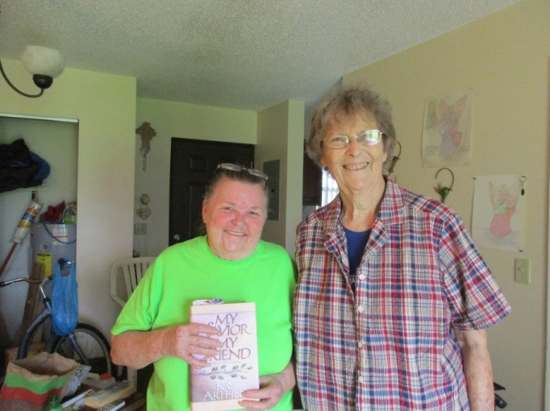

Below Judy blesses our Deacon Maria Elena Sierra Sanchez from Colombia as she is ordained a Priest at our Good Shepherd Inclusive Catholic Church by Bishop Andrea Johnson (rear) on 2/25/17.
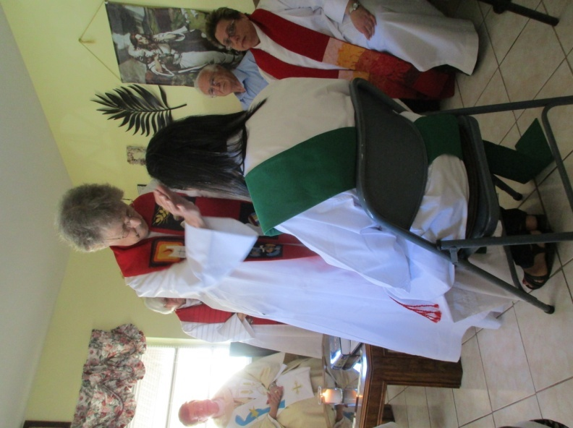
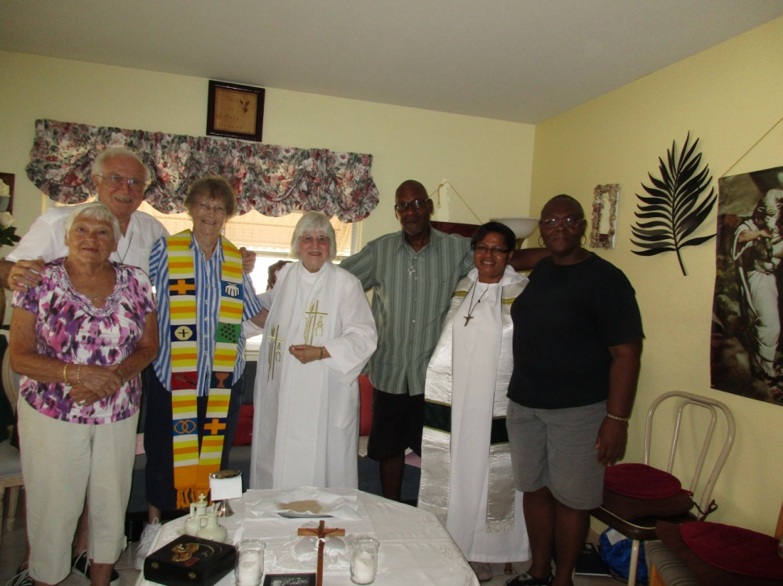 With members of our Good Shepherd Community in the Easter season 2017 (‘Deacon” Hank Tessandori, Ann Palmer, Elder Harry Lee Peter Gary and Pastor Marina Teresa and Phyllis Williams
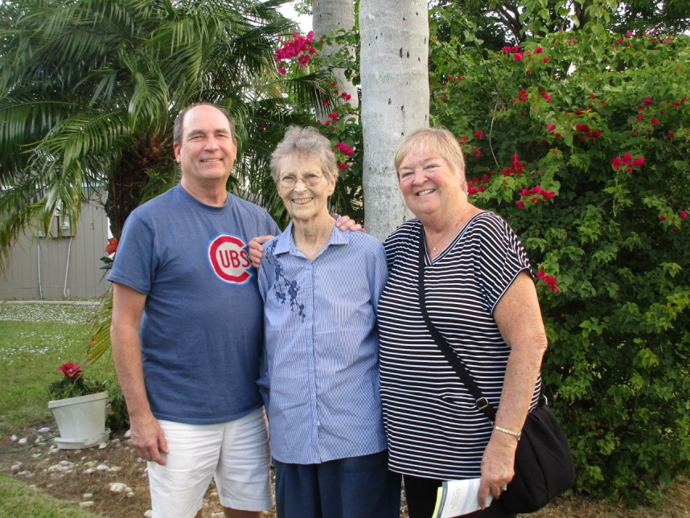
Here Judy’s brother Ed and his wife Joanie visit in early September,2017

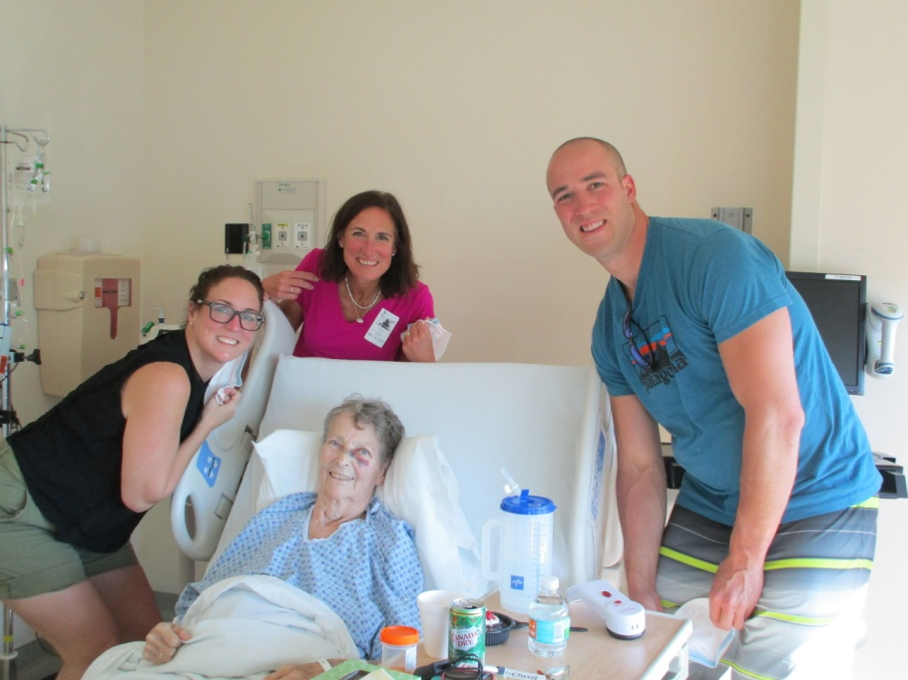 Judy’s nieces Julie Covill (middle) and Jenny Bergner and nephew Chris Bergner visit her in the hospital in November 2017 and her smile tells how happy she is that they came. Julie came from England and Jenny and Chris from Chicago. A few days after, her niece Kristen and her husband Kevin Ryder and two small children also visited from England. Judy was so happy to see them however briefly and to meet baby Ella Rose. Little Sammy had a good conversation with her and she was delighted. Our friends from California, Carol Swenson and David Hoover also visited. This hospital stay was short and this time was a love feast that blessed all.

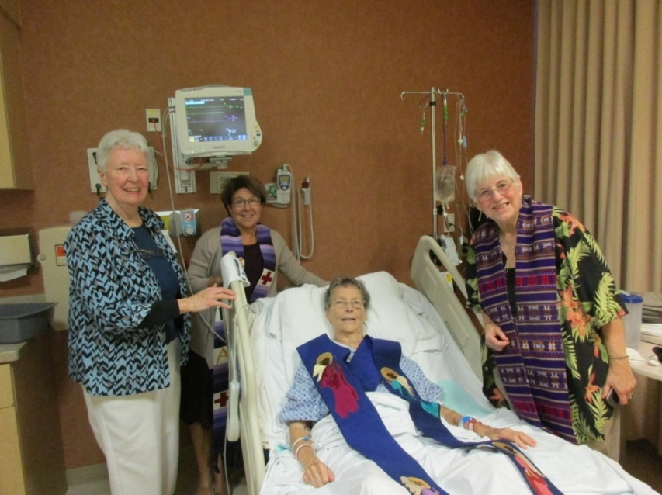 Here Judy celebrates her 80th Birthday, 12/10/17, with Sr. Patsy Crowley, her dear friend from her Benedictine Community in Chicago, and Judy Alves representing our Good Shepherd Community. Her beloved sister Jill is taking the picture. She is wearing her stole as she was able to participate in the prayers and also to bless all of us and the hospital personnel who came in. Judy said that she was very happy to be with us and to celebrate this birthday, but she wished it were not in the hospital. She was soon discharged and a week later, as she was ready for it, we went on home hospice.
Final Affirmations-Of Love, Of the Priesthood
There were many affirmations of her love and faith and two beautiful affirmations of her priesthood as she neared the end. It was during this hospitalization that Judy met a caring doctor who was a devout Catholic. They chatted and he asked if Judy wanted to see a priest that both she and he knew. Judy easily agreed though she said that I had already anointed her. This doctor was kind and respected her but was not in agreement with our priesthood. When the priest came we were happy for him to anoint her also. But when he asked Judy if she wanted to repent for taking Holy Orders, she asked him if he wanted to repent of his priesthood? When he said “no” she replied that she was blessed to be able to answer God’s call as he was, and there was nothing to repent. He anointed her and we all blessed one another. She remained confident in God’s call and courageous even now.
Judy’s priesthood was precious to her, as was the RCWP Movement-and sounding the alarm to the church not only for its priority on their rules and finances rather than the poor but for arbitrarily deciding that only celibate non (openly) gay men could be priests-the audacity of telling God whom God can call to ministerial service when so many people needed loving service and care.
In Judy’s last week when our former Bishop and friend Bridget Mary called her with pastoral care, Judy was pleased and thankful. I shared Bridget’s words of peace and encouragement including her words: “the angels and saints and all you love are waiting and coming for you”. Judy listened and replied: “I don’t know about the angels but I know God is there. Our loving God is and will be there.” She motioned for the phone. I held the phone while she listened and then told Bridget Mary “Thank you for being my friend, and thank you for ordaining me a Priest. It means everything. And, God bless you and our sister priests in the Movement.”
Life was so precious to Judy and she lived it every day, appreciating the little gifts of love and peace that each day offered, a hand held, a snuggly cat or dog, a sip of water, a smile or a call from a loved one, especially Ed, or word from Jill and me or a kind nurse or aide. She pushed herself to go for the blood transfusions and did not accept or feel like she was dying until near the end. When she finally knew her time of release was nearing Judy told me three things at different points in time: “I love you and thank you for taking such good care of me”; “I am dying” and, later, “let me go.” I could barely reply to her love and thanks without tears except to say it was my greatest honor to care for her, and “thank you for caring for me and putting up with the many ways I can be so difficult over the years. I will love you forever.” She nodded and we held hands. Jill and I assured her that we were with her and that Jesus is very near to take her on this last journey-we would let her go to our loving God. This was so hard, but we felt too that her love would be with us forever, and told her this, and that our love will go with her. When I told her that she was already my angel but asked if she could be my angel from beyond as well, she said, “If God allows it I would love to do it.” She was so full of love even honoring my selfish request, “if she could”. She knew that she had yet to learn what being with God was like, what life is when we continue on with God. As if to grapple with it, and also because she was sorry she could give no more, she wrote on a donation form to Mary’s Pence “I cannot give any more as I am dying, but I wish I could.” I did give to that good organization for her when I found this. I knew how much she gave of herself in every way and how she wanted to keep on doing this. As she listened to the strains of Te Deum, chant from the Pennsylvania Benedictines, or the Christmas carols in the background she smiled and was enveloped in peace. Yet, my heart was breaking for her, however ready she was for the next Chapter to begin, she loved this life and letting go of it was hard beyond what we knew. Jill said that Judy wanted to live for me, I acknowledged that great love, but added that she wanted to live to keep on serving as well. Judy arranged to keep on giving after her death in a material way by donating her body to the University of Miami, Miller School Of Medicine. This is consistent with what her mother did with her body after talking with Ed who told how important the cadaver was to a medical students’ learning. Judy’s life is the gift that keeps on giving well beyond the grave.

Priest Until the End
Judy was a priest until the end and beyond. In her last two weeks she blessed those who came to see her or help her with inspired personal blessings. We limited visits but she blessed our neighbors Sonja Miller, Doris Broughton and Greg Pearl and thanked them for their wonderful assistance as it was needed. When Pearl and Efe Cudjoe and Pastor Marina visited we said the Rosary with her. She then blessed Pearl and her love for all of the children in the Orphanage in Ho, Ghana, Africa that our Ministry had supported, and for raising wonderful children and serving others at Good Shepherd. She blessed Efe and prayed that she may become a gifted doctor who shares healing and compassion with all she treats. And she blessed Pastor Marina that her life and Ministry may progress in every way, and remain full of love and justice. She also raised her hands in blessing for our Good Shepherd member and young friend, Gaspare Randazzo who has helped with the care of our birds and cats since my illness in 2013. Her “thank you”, warm smiles and blessing helped him to see passing as full of love, not fear.
When our dear Veterinarian Dr. Terry Sutton came Judy was petting our three legged cat Timmy who cuddled with her. Timmy and she had a special bond as they fought cancer together. Terry knelt down at her side and spoke of the peace she felt in this household and with Judy. Judy reached out and put her hand on Terry’s head and prayed that she would be able to remain strong to continue her compassionate care of God’s littlest creatures as well as their human companions. She gave her blessing as Terry wiped tears and promised her that she would look out for me too. What a lovely moment that was for all of us.
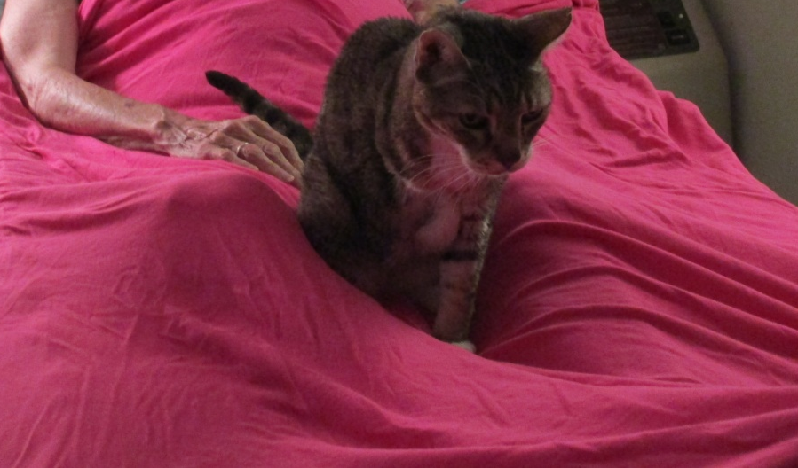 Timothy Stays Close

Several times Judy thanked Jill and me separately and together for taking care of her and loving her so well. We assured her that we thanked her with all our hearts and will love her forever. She said that she will love us forever. Judy and I were both so thankful for Jill’s presence with us during this last time.
One day, as Jill and I sat by her side as she rested, Jill said that the passage about finishing the race from Timothy suited Judy perfectly. I agreed and got my Bible and looked up 2 Timothy 4:6-8 and read it to Judy.
“I have fought the good fight. I have finished the race. I have kept the faith. Now there is in store for me the crown of righteousness….and not for me only but also to all who longed for his appearing.” (Righteousness also means justice in this context). Judy was nodding as I read it and Jill held her hand and said “Amen”. I said we know you don’t want a crown of jewels, but the crown of justice is yours for you have spent your whole life working for it. She smiled and nodded. I then added from Matthew 25:21 “Well done, good and faithful servant….Come and share your Master’s happiness.” Judy opened her eyes and smiled at us and nodded, then rested.
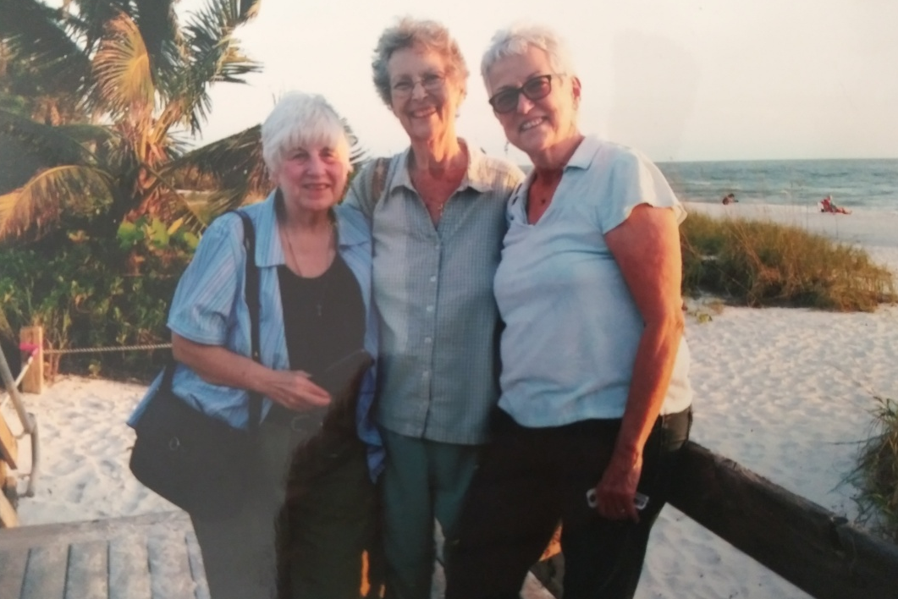

In Chapter Twelve I shared how Judy and Jill prepared wonderful Christmas surprises for me and how she thought of me and our family until the last, making a herculean effort to sit up with me by the Christmas tree as we always did. Her thoughts were for others even as she moved toward the bridge.
Henri Nouwen was a favorite theologian and writer of both Judy and Jill and they received daily email meditations from the Henri Nouwen Society. In March of 2019 his meditations were on death as a journey and making our deaths fruitful (from his book “You are Beloved”). On March 28th he writes that Jesus saw his death as potentially fruitful. “ ….My death will bear many fruits beyond my death. When I die I will not leave you alone,but I will send my Spirit….to reveal to you who I am ,what I am teaching you….” In another place he said “Unless a grain of wheat falls to the ground and dies, it remains just a grain of wheat;but if it dies it produces much fruit.” (John 14:24-26). Nouwen asks: How can I then live so that my death will be fruitful to others? In other words, how can my death be a gift for my loved ones so that they can reap the fruits of my life after I have died?” Through witnessing the way that Judy lived AND died we can not only “reap the plentiful fruits of her life” but also receive the spirit of love she left us with. On March 30, 2019 Nouwen’s meditations note: “We support one another through the passages of life, and together we grow in love. Finally, we ourselves are called to exodus, and we leave the world for full communion with God. It is possible for us,like Jesus, to send our spirit of love to our friends when we leave them. Our spirit, the love we leave behind, is deeply in God’s Spirit. It is our greatest gift to thoses we love.” Jill commented to me that Judy taught us not only how to live in Christ, but how to die. That is so true- and a fruit of her dying and death.
Nouwen also said (in Bread for the Journey,1997,Harper) in the May 17,2019 Meditation “when we approach our deaths let us say to those we leave behind,’Don’t let your heart be troubled. The love of God that dwells in my heart will come to you and offer consolation and comfort”. Indeed, ths is true.
It was the morning of January 1st, 2018 and Judy breathed softly and evenly. Then there was a sort of shudder and I called Jill who was lightly asleep in the nearby chair and she hurried in. We sat on each side and leaned toward her, touching her arms. In a last great effort she expelled her last breath upon us with a gutteral uttering. We bowed our heads at her last blessing, at her sharing of her spirit with us, imparting her spirit to us, as she left this shore and crossed the bridge to life with our loving God. The moment was the holiest of holy moments.
I said “She’s gone home”. Jill took her pulse and nodded. We could not believe the moment although we knew it was coming. How could she be gone from us? But she wasn’t gone completely because she imparted her spirit to us in one last holy and perfect gift.
As we called for the Hospice personnel to come and pronounce her death and do the last things they do we cried and consoled one another. Then, we stood quietly in her presence and I said what God laid upon my heart: “She is not here, she is risen”. And Jill nodded and agreed.
Risen and Fruitful Beyond Death
When I said that “she is risen” I knew it in the depth of my spirit and being and my faith affirmed it. For Jesus said “I am the resurrection and the life, S/he who believes in me will live,even though s/he dies”. (John 11:25). Judy not only believed with her mouth and all her heart, but with her every act, she believed through living and doing the gospel. She lived a Matthew 25 life feeding and tending the lost sheep every moment of her life. Even if she hadn’t, Jesus made a way for those who love him to live forever with him. Yet her life showed us the way to follow Jesus. And she still shows us the way.
Seeing and Experiencing the Risen and FullyLiving Judy
In October of 2018, while participating in the Ordination of two Deacons in the Eastern Region of the Roman Catholic WomenPriest Movement, I was given the most special and unexpected gift that assured me of Judy’s life and of eternal life and resurrection beyond a doubt or worry.
People who know me know that, like Judy, I love God and God’s people, especially the “little ones” through my actions- through serving. I am not a “mystic” and while I experience the reality of God in many ways, I do not have what one of our sister Priests from Arizona, Marilyn, calls “woo woo spirituality.” I am not one who seeks or prays for or expects visions or special spititual moments though some have happened to me. I draw from the awesome beauty of all God’s creation and creatures, and from the depths of Holy Scriptures. A little lake behind my house is my most holy place where my heart can spontaneously say “thank you” to God, no matter what. I do not ask or expect to see things or signs. A feather is just a feather to me and a cardinal is just a most beautiful bird. And all feathered and furred creatures and all people are beautiful and their lives sacred.
Before the extraordinary experience of Judy that I am going to share, I experienced three other very special times of revelation. The first was as a child when I was moved while listening to a religious radio program with my devout and beloved Grandma to “give my heart to Jesus” in response to Jesus’ love for me. I knew that I was called to follow Jesus forever. My call to serve the homeless came through my heart being moved to breaking by witnessing the homeless in Washington Square Park in New York City up close and personally. I crossed the park every morning from NYU faculty housing where I lived as I taught Masters’ level social work students, some of whom were also dual degree MDiv students that I mentored and enjoyed being in dialogue with. Talking with and experiencing the people who slept on the benches, particularly the women, made me sad and uneasy and kept me up at night reading the Scriptures. One night in 1982 I read Jesus’ call in Luke 4:14-20 and Isaiah 61:1-2, and I cried as I realized it was my call too-“to preach good news to the poor”-by my actions, and, if necessary use words. The next day I began my work in the City shelters and ministry with the homeless. This was a call Judy and I shared and a basis for our lives and ministry together. God spoke to me through my heart, through people and through the Scriptures. And by 2007 this extended to a call to become a pastor, a shepherd of the lost flock and a priest. God speaks and makes known God’s will in so many ways, but those were watershed turning points for me.
And, again, as I attended St. Ann’s Church in Avon, Connecticut, with Judy I had a very special experience of affirmation. We were visiting there as they were making a donation to My Sisters’ Place. It was near the beginning of our time together and I so enjoyed going to church with Judy. I was studying Catholicism with our St. Michael Parish Priest and looking forward to Initiation into the Church. Anne was also my mother’s name. I had lost her two years or so before suddenly to a coronary event. She was not yet 74. I missed her and she was often on my mind and heart especially as I attended St. Ann’s. My heart was full of emotions. As I prayed and looked up at the altar my mother, Anne, was standing in a grotto- like space of maybe two feet to the right and above the altar-not close but in my view. She was looking at me and wearing the clothes she usually wore and was happy and healthy looking. As I looked up and prayed I heard her say “It is okay, dear, it is okay”. I could hear her voice and see the peace and happiness she had. I believed that she was saying, “She is okay”- with God. And also it is “okay” to build a life with Judy and to become Catholic. It was as if she were giving her blessing. Such a gift! I never saw her before or after this, not even in dreams, but this was enough to put my heart at peace.
I share these experiences to give context to what I am about to tell you. In a long life, those are my three “out of the ordinary” spiritual experiences-my calls to follow and to serve and the experience of my mother’s blessing. Judy had gone home to God on January 1st of 2018 and the Ordination was at a retreat on October 15, 2018. It was the first time I rejoined our group of priests since her death and it was a hard time for me. Judy and others had also been remembered in an opening Memorial Mass the day before. I was pleased to be with my priest sisters and at the Ordination especially, but being there without her made me feel lonely and sad. When we sing the Litany of Saints as part of the Rite of Holy Orders our deceased priests are added to the list of saints. When I heard Judy’s name in the Litany I began to cry quietly but visibly enough that the priests near me, Marie and Marilyn, comforted me. When Judy’s name was prayed so beautifully by the cantor, Karen Murphy, it was clear that she was now among our saints and we were imploring her and them to pray for us. My heart had to realize: she is really there among the saints. And then I realized she is really here praying for us.
I went up and joined the group in laying hands on the deacons-to-be, Fran, a former Sister whom I would be mentoring, and young and brilliant Celie. I sat down and prayed for Celie and Fran. Fran was in my line of vision, maybe fifteen to twenty feet away, and suddenly I looked up at her as there was a long break in the line of people blessing her. The sun from the window was very bright around Fran but it became immeasurably brighter and whiter as our beloved Judy Beaumont, fully alive and whole, full of health, and very much herself as if at the prime of her years, stepped forward and placed her hands over Fran’s head. She was her best self with white skin, not etched in lines or badly bruised and marred as at her end, with short dark rich wavy hair and bright hazel bluegreen eyes shining,twinkling. She was in a startling white robe, maybe her alb or another robe, no stole and no glasses. Her outstretched hands had no discolorations of the AML leukemia. Her smile at Fran was beautiful she and Fran were gently glowing. And then she turned directly toward me and smiled at me, her eyes loving and joyfully happy- looking at me and giving me her wonderful smile. While my Mom had appeared far away, Judy was so close I could easily move forward and touch her but I remained fixed in my seat. I was immediately filled with her love and life as that smile was just for me and I smiled back. I gasped aloud and felt the joy that she lives now,whole, beautiful and joyful and full of blessing-even more fully blessing others now than when she lived on earth. And suddenly I knew what Paul felt like when he was knocked off his horse on the road to Damascus as he saw and encountered the living Jesus. The experience could not have been more real, for it was the essence of reality. I was so reassured and so happy that she appeared to me for those few moments, fully alive and whole. I was amazed, stunned and so deeply happy. She lives! She lives and blesses us!
I was not surprised that she appeared in the holiness of the Ordination and not in a dream as I have had no dreams of seeing her and no other moments with this profound level of reality. And, Judy was always holy but perhaps it was all of us praying and the prayers and the holiness of the moment that brought her through the thin space that separates us from the other side. She came to affirm the ministerial priesthood of women that she so loved. And, she came to assure me in the depth of my faith and grief and missing her during the holy times that we shared together, that she is fully alive as Jesus promised she would be. And, I think she came, too, clearly to bless both Fran and Celie, our youngest deacon and priest to be, and to approve and bless my mentoring of Fran and assure me of her assistance and presence.
THANKS BE TO GOD for this great and unexpected gift!
I shared this experience in an email the following day to the other priests as I could not speak of it right away. Another priest present, Rev. Theresa Chabot wrote me that she too experienced a special and amazing white glow around Fran when there was a lull in the people blessing her. She thought it was when I saw Judy. And our sister priest Rvda. Marina Teresa, who could not see me during the Ordination, told me that she too was overcome with tears during the sacred ceremony after the Litany of Saints and she thought it was because of Judy’s presence.
And so, by faith in life eternal and the resurrection, and by the power of this experience I affirm joyfully that “She lives” once again.
Judy’s life was totally fruitful and her death was the same. She imparted her spirit of love and seeking peace and justice to us to cherish forever and to give to others. The full fruits of her life and death are yet to be reaped. They will be fruits of faith, of service, of justice and of activism for peace and for the least among us-for inclusion. Perhaps those reading this book will take hold of those fruits and her meaning to them and carry it on- into their own lives and their families’ lives, into other places and other lands. Yes, carry it on!
And, finally, I am remembering what she asked of me so long ago: “All I ask of you is forever to
remember me as loving you.”
What a gift, for all of us, forever! Amen!
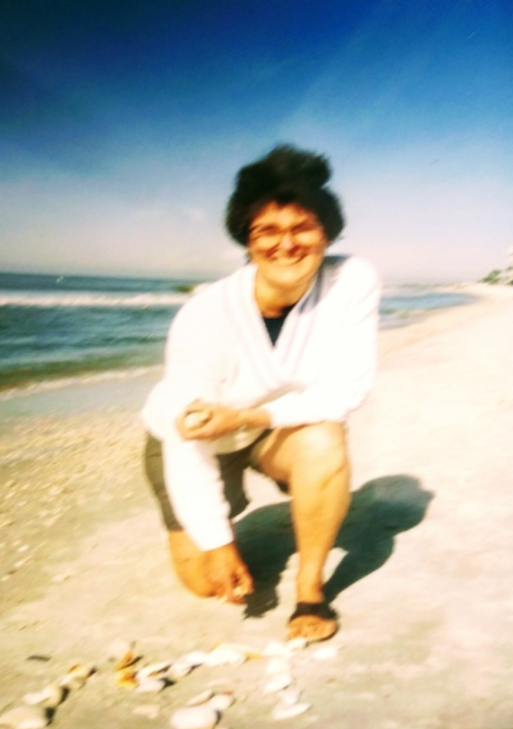 Love letters in the sand

You are the Body of Christ! AMEN! AMEN!
